About This Document

Overview

This document describes the steps to build and deploy and run myVodApp web application.

What You Need

## Pre Requisites

## Supported Operating System

Windows XP/7

## Supported Browsers

Firefox 37.0.2 /Google Chrome/IE11

## Installed Software

Below is the list of software that should be installed on the system:

| **No.** | **Software** | **Version** |
| --- | --- | --- |
| 1 | Java Software Development Kit | 6 |
| 2 | Apache Maven | 3.2.x |
| 3 | Apache Tomcat | 7.0.x |
| 4. | PHP | 5.5.x |

## Pre-set environment variables

| **Variable** | **Description** | **Remark** |
| --- | --- | --- |
| JAVA_HOME | The home directory for JDK. | Should be set to something like **C:\Program Files\Java\jdk1.6.0_45** |
| M2_HOME | The home directory for Maven. | **D:\apache-maven-3.2.5** |
| PATH | Add additionally the paths to **java** and maven **bin** directories and **php** installation directory | PATH=%PATH%;**%JAVA_HOME/bin%;%M2_HOME%/bin;** **D:\php-5.5.37-Win32-VC11-x86** |

How to build

## Download and copy the project folder

Download the myVodApp project folder from the provided ‘Github’ url and copy on to the system local disk.

Below shows the folder structure of the downloaded project folder downloaded to destination

‘D:\Workspace\myVodApp’

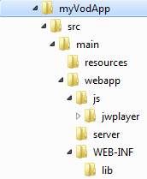

## Build the project

The project uses Maven build scripts. It is recommended to have some basic knowledge about Maven.

Steps to build:

1. Open command terminal from run.

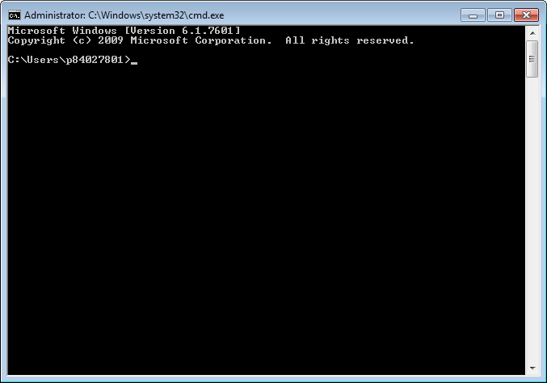

1. Navigate to project root directory. In this example ‘***D:\Workspace\myVodApp’***

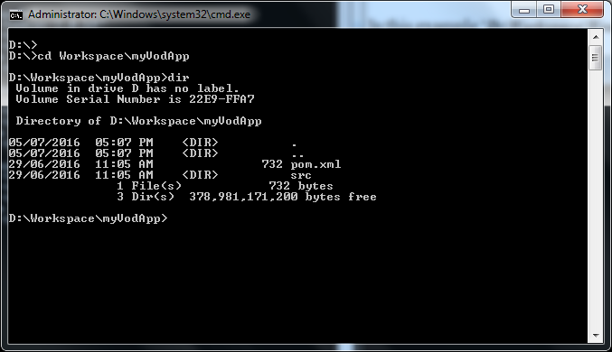

1. Check JAVA_HOME, M2_HOME and PATH variable is set properly:

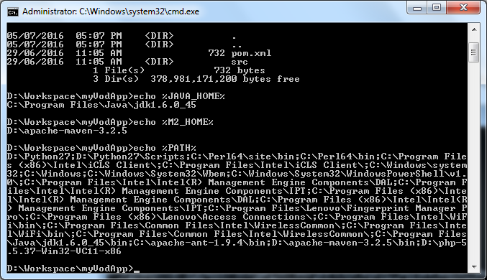

1. Build the project by executing below command:

‘mvn clean package

D:\Workspace\myVodApp>mvn clean package

[INFO] Scanning for projects...

[INFO]

[INFO] ------------------------------------------------------------------------

[INFO] Building myVodApp Maven Webapp 1.0-SNAPSHOT

[INFO] ------------------------------------------------------------------------

[INFO]

[INFO] --- maven-clean-plugin:2.5:clean (default-clean) @ myVodApp ---

[INFO]

[INFO] --- maven-resources-plugin:2.6:resources (default-resources) @ myVodApp -

--

[WARNING] Using platform encoding (Cp1252 actually) to copy filtered resources,

i.e. build is platform dependent!

[INFO] Copying 0 resource

[INFO]

[INFO] --- maven-compiler-plugin:3.1:compile (default-compile) @ myVodApp ---

[INFO] No sources to compile

[INFO]

[INFO] --- maven-resources-plugin:2.6:testResources (default-testResources) @ my

VodApp ---

[WARNING] Using platform encoding (Cp1252 actually) to copy filtered resources,

i.e. build is platform dependent!

[INFO] skip non existing resourceDirectory D:\Workspace\myVodApp\src\test\resour

ces

[INFO]

[INFO] --- maven-compiler-plugin:3.1:testCompile (default-testCompile) @ myVodAp

p ---

[INFO] No sources to compile

[INFO]

[INFO] --- maven-surefire-plugin:2.12.4:test (default-test) @ myVodApp ---

[INFO] No tests to run.

[INFO]

[INFO] --- maven-war-plugin:2.2:war (default-war) @ myVodApp ---

[INFO] Packaging webapp

[INFO] Assembling webapp [myVodApp] in [D:\Workspace\myVodApp\target\myVodApp]

[INFO] Processing war project

[INFO] Copying webapp resources [D:\Workspace\myVodApp\src\main\webapp]

[INFO] Webapp assembled in [163 msecs]

[INFO] Building war: D:\Workspace\myVodApp\target\myVodApp.war

[INFO] WEB-INF\web.xml already added, skipping

[INFO] ------------------------------------------------------------------------

[INFO] BUILD SUCCESS

[INFO] ------------------------------------------------------------------------

[INFO] Total time: 2.186 s

[INFO] Finished at: 2016-07-05T17:12:26+10:00

[INFO] Final Memory: 7M/245M

[INFO] ------------------------------------------------------------------------

D:\Workspace\myVodApp>

The command will run compile the project. If the build is successful the included Junit test case passes the final war file ‘***myVodApp.war*’** will be created under ‘***D:\Workspace\ myVodApp \targe****t*’ folder

How to deploy

## Copy the war file to Apache Tomcat Server

Copy the recently built application war file, ***myVodApp.war***, from last set to ‘webapps’ under installation folder

e.g. ‘***D:\apache-tomcat-7.0.59\webapps***’

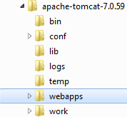

## Restart Apache Tomcat Server

Execute below scripts by navigating to bin folder under tomcat installation one after another.

shutdown.sh 🡪 startup.bat

Wait sure and make sure tomcat server is completely initialize, up and running

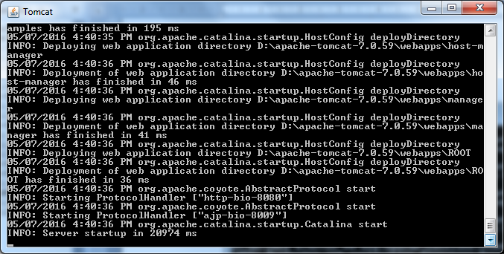

*Note: No need to execute shutdown.bat if tomcat server is not running.*

## Access the myVodApp from brower

Open the url ‘<http://localhost:8080/myVodApp/>’ from supported browser:

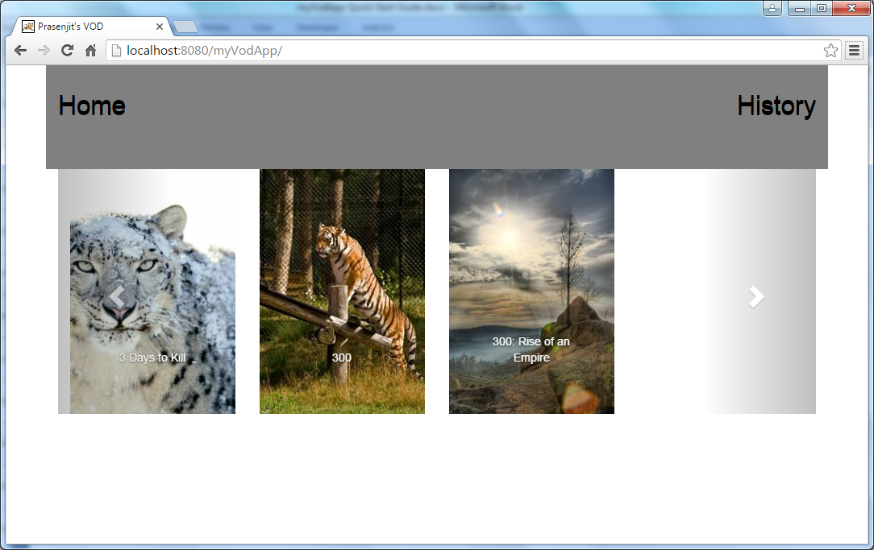

Troubleshooting

## Common Error

If something like below is been seen, it normally means that the application encounter communication error or other exception while getting data from online.

***Suggested Action: Please check your internet connection and try again.***

